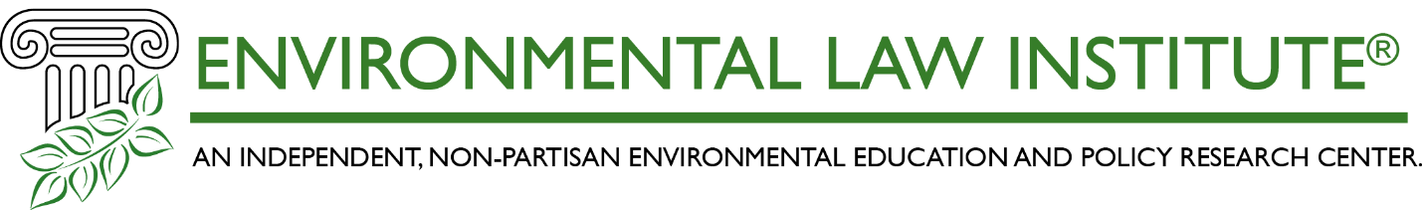

Wetlands and Hazard Mitigation
_____________________________________________________________________________
Opportunities for Integration

October 31 and November 1, 2023

Virtual Training Workshop Agenda

This project is made possible through a Wetland Program Development Grant funded by the
United States Environmental Protection Agency

PURPOSE OF THE TRAINING WORKSHOP

The workshop will identify opportunities for using wetland and floodplain restoration and protection prioritization methodologies in hazard mitigation planning.

WORKSHOP OBJECTIVES

- Provide an opportunity for wetland agencies and hazard mitigation planners to discuss opportunities for using wetland and floodplain restoration and protection prioritization tools and methodologies in the hazard mitigation planning process.
- Discuss how to build partnerships among wetland and natural resource agencies and organizations and hazard mitigation planners and project developers.

AGENDA
(All Times Eastern Daylight)

Day 1

12:00 pm – 12:15 pm Welcome and Workshop Objectives
- Rebecca Kihslinger, Senior Science and Policy Analyst, Environmental Law Institute

12:15 pm – 12:45 pm Session 1: Nature-Based Strategies for Hazard Mitigation
In this session we will discuss how natural infrastructure and nature-based strategies provide hazard mitigation benefits. Specifically, the presentation will discuss what has been learned from implementation of nature-based hazard mitigation projects (including from success and failures).

- Emily Donahoe, Policy Specialist for Resilient Coasts and Floodplains, National Wildlife Foundation

12:45 pm – 1:45 pm Session 2: Hazard Mitigation Planning: Points of Entry
This panel will discuss hazard mitigation planning and provide case studies of what states are doing to integrate nature-based strategies.

- Logan Sand, Senior Community Planner, FEMA Region 8
- Caroline Paske, State Hazard Mitigation Planner, Vermont Emergency Management
- Jim Marwedel, Hazard Mitigation Planner, Iowa Department of Homeland Security & Emergency Management

1:45 pm – 2:00 pm Break

2:00 pm – 3:15 pm Session 3: Wetland/Stream Restoration and Protection Prioritization Tools
This panel will provide case studies on wetland and stream restoration and protection prioritization tools. The panelists will describe their methodologies, how the tools have been used, and opportunities for further integration in the hazard mitigation process.

- Will McDow, Senior Director, Climate Resilient Coasts and Watersheds, Environmental Defense Fund
- Rachel Byrd, Geographer and GISP Geospatial Professional, U.S. Army Corps of Engineers, and Laura Mattingly, Planner and Project Manager, U.S. Army Corps of Engineers
- Justin Bousquin, Social Scientist, Environmental Protection Agency
- Eugene Yacobson, GIS Analyst, The Nature Conservancy

3:15 pm - 5:00 pm Session 4: Breakout Discussions 1 – Integration at the Site Scale:
We will discuss opportunities for using wetland and floodplain restoration and protection prioritization tools and methodologies in the hazard mitigation planning and project development process at the project scale.

Breakout groups will collaborate to identify 3 priority action items/ resources to address the issue.

5:00 pm Wrap-Up

Day 2

12:00 pm – 12:15 pm Welcome and Workshop Objectives

12:15 pm - 1:00 pm Session 5: How to create good projects (and avoid bad ones)
This session will discuss ways to ensure that nature-based projects are designed and managed to yield projects that meet their desired objectives and provide multiple benefits to communities (and avoid ill-conceived projects).

- Viv Bennett, Director of Protection and Conservation Strategies, The Nature Conservancy

1:00 pm – 2:30 pm Session 6: Breakout Discussions 2 – Integration at the Watershed Scale: We will discuss opportunities for using wetland and floodplain restoration and protection prioritization tools and methodologies in the hazard mitigation planning and project development process at the watershed scale.

Breakout groups will collaborate to identify 3 priority action items/resources to address the issue.

2:30 – 2:45 pm Break

2:45 – 3:30 pm Session 7: Partnership/Community Capacity Building
Partnerships are key to scaling-up nature-based projects at the local level. This panel will discuss the challenges and opportunities to build partnerships among natural resource agencies, hazard mitigation planners, and local governments.

- Mary-Carson Stiff, Executive Director of Wetlands Watch
- Lance Davisson, The Keystone Concept, and Zachary Christin, Equilibrium Economics, “Ecosystem Services Valuation for Natural Capital”

3:30 – 5:00 pm Session 8: Discussion –Partnership Building
This breakout session will allow participants to discuss the resources needed to build partnerships among natural resource agencies, hazard mitigation planners, and local communities. Breakout groups will further discuss how to build partnerships among workshop participants and what research and/or policy development is still needed to scale up nature-based projects.

Breakout groups will collaborate to identify 3 priority action items or resources that will help build partnerships and community capacity.

5:00 – 5:30 pm Wrap-Up

